\aTopics:
- Storage - Joaquin
- Cleanliness - Joaquin
- Certain Chestnut ones - Paige
- Personal Efficiency
  - Already done
- UofT non- classroom - Isabelle & Kevin

Storage:
Condensation on Cold Beverages:
- Trying to fix condensation on beverages because its uncomfortable and has potentially damages surfaces the beverages are placed on
- Requirements:
  - Reduce discomfort
  - Reduce severity of water rings
  - reusable
  - Convenient for daily use
  - Wide array of applicable cups
  - Reduce environmental impacts

Tangled Computer Power Cables (TCPC):
- Prevent or reduce power cables getting tangled because it's inconvenient and reduces the efficacy of the power cable themself
- Requirements:
  - Reduce time untangling wires
  - Minimize damage to cables
  - Minimize cost
  - Maximize cable service life of cables
  - Minimize space taken up
  - Maximize durability of Cable (same as lifetime????)
  - Maximize safety of design
- Refrence designs are some variation of wrapping the cables together and tying them

Protect books from damage:
- Prevent the damage from the exterior of the books
  - Placing books in backpacks damaged the books
  - Causes further issues as you have to pay or replace books
- Requirements:
  - Usability:
    - Protect front cover, back cover, corners, tail and textblock from mechanical forces
      - Liquids
    - Time to required to employ the solution should be short
    - Lightweight
    - Compatible with a variety of book sizes
      - Book material
    - Compact when not in use
    - Durable
    - Cheap for customers
    - Minimize greenhouse gas emissions
  - Reference designs are some sort of covering on top of the covers, but does not work for soft covers

Cable Management Efficiency:
- Create a way to organize wires while within backpacks
- Requirements:
  - Reduce untangling time
  - Reduce time for winding, organizing and storing
  - Reduce length of cable that becomes uncoiled form the rest of the wound cable
  - Usable for different cable lengths
  - Usable for different diameters
  - Usable fro various stiffness
  - Easy to organize
  - Reduce manual labour to wind laptop cables (why very specific to laptops)
  - Reduce adverse effect on wire due to coiling and winding
  - Organize many wires

References designs:
- Wireless charger
- Retractable charger (like a measuring tape)
- Cable organizer bag
- Vacuum cable

Cleanliness:

Dirty belongings:
- Reduce dirtiness of belongings after floor is tracked with snow, slush and mud.
- Objectives:
  - Maximize cleanliness of surfaces
  - Minimize the amount of dirty liquid being absorbed into the backpack measured based on the DAC
  - Minimize time it takes for the design to be used
  - Cheaper design
  - Follows COVID-19 Guidlines
- References Designs:
  - Shoe Covers
  - Door mats

Umbrella drying:
- Prevent or reduce the water/puddles created from a drying umbrella after being used in the rain.
- Requirements:
  - Dry umbrella enough to prevent hazardous water
  - Fits all common umbrella sizes
  - Low cost
  - Time efficient
  - User friendly
  - Lightweight
  - Compact
- Requirement designs
  - Some sort of air blowing device like hand driers

Chestnut Splartz:

Eco2Go:
- Redesign the System to allow for faster times through the caf and less interaction between staff and student
  - Faster thru time
  - Less steps (when staff not posted)
  - Less space
  - Less time
  - Sanitization
  - Environmental impact

Laundry Room:
- Improve Laundry Availability
  - Efficiency
  - Financially viable
  - Usable
  - Engsci achievable
  - Profitable
  - Accessible

Straws:
- Better straws for smoothies??
  - Environmental impact
  - Production cost
  - Speedrun drinking a smoothie
  - Less spills
  - Less hand movement
  - Safety

Utensil Aquisition:
- Make the utensil stand not gross
  - Usability (speed and access)
  - Covid safety
  - Environmental impact

Trash:
- Better system to reduce overflow and increase sanitary conditions
  - Affordable
  - Efficient
  - Maintainability
  - Accessible
  - Sustainable
  - Opinions of users and caretakers of usability are considered
  - Limits recyclables in waste bins

Non-Classroom Splartz:

Adjustable laptop Chargers:
- Design a laptop charger with adjustable length for u of t students
  - Be adjustable
  - Easy to set up and pack up
  - Be portable
  - Keep charging wire protected

Better Flushing Mechanism:
- Design to resolve the inconsistent effectiveness of the toilet mechanisms used in u of t washrooms (refers to the automatic flush using motion detectors)
  - ‘Add-on’ -- easy to install for most average toilets
  - Effectiveness
  - Feasibility
  - Usability
  - Safety
  - Reliability
  - Maintainability

Better Seating:
- Improve the design of seating installations without back support found in and outside engineering buildings at U of T, and fixed installations which may be used for seating by students.
  - Maximize postural alignment of the pelvis, lumbar spine through lumbar support
  - Be usable with a variety of seating configurations without pre-existing back support
  - Be able to be removed, easily transported, and stored.
  - Safely withstand significant amounts of accumulated loads over time.
  - Provide comfortable back support for a range of student bodies.
  - Minimize environmental impact by enhancing current available seating instead of
acting as a replacement system.

Charging devices:
- Resolve need for charging devices on campus by designing a system/service for u of t students
  - Supports majority of device types
  - Easily accessible
  - Minimize cost (free for users, minimize cost for institution, may use renewable energy sources)
  - Provide the appropriate amount of power to each device

Charging spaces:
- Implement practical, reliable and safe device-charging system available to u of t students on campus
  - Be safe to use
  - Be easily accessible, recognizable and convenient
  - Be compatible to charge a variety of devices
  - Be durable
  - Be affordable for u of t students, and faculty

Finding Study Spaces-1:
- Improve the experience of finding an individual study spot in MY and BA through the implementation of a physical solution on site
  - Minimize time spent looking for a study spot
  - Be cost-efficient
  - Reduce additional fatigue caused by searching for study spots
  - User is able to easily extract information from display
  - Minimize actions required to identify available spot
  - Identifier of available spots should be visible

Water Splash Back:
- Design system that will reduce water splash back from Sanford Fleming sinks
- Objectives
  - Reduce back splash
  - Prioritize accessibility
  - Quick install
  - Clean easily
- Gives reference designs but does not point out their issues

Vending Machines:
- Design system that will prevent lodging issues in vending machines
- Objectives
  - Minimize time taken for getting stuck snack
  - Require least amount of effort
  - Effectively dislodges stuck snack
  - Be cost efficient
- Nope

Snow and Slush in Buildings:
- Reduce dirty tracked in from the outside during the winter season
- Objectives
  - Accommodate flow of traffic
  - Be accessible for all users
  - Be safe for users and property
  - Keep footwear dry
  - Be resistant to slipping
- Something to clean shoes at the entrance/dry them

Overflowing Garbage:
- Improve experience of public trash receptacles
- Objectives
  - Appropriate size and capacity
  - Be usable
  - Be durable and easy to maintain
  - Be accessible
  - Be affordable
- Something like a better compactor?
  - Why not increase cleaning

Better Sorting System for Garbage:
- Improve waste disposal system
- Objectives
  - Minimize time it takes for user to dispose waste
  - Maximize accuracy of sorted waste
  - Accessible to all users
  - Inexpensive
  - Allows user to throw multiple types of waste
- Will probably lead towards automation

Sorting food and liquid waste:
- System to sort solid and liquid waste
- Objectives
  - Make process easier for user
  - Ease process for janitors
  - Separates solid and liquid waste
  - Be reasonable in size
  - Not leak waste
  - Economical
- Okay, probably has easy solutions ie. strainer of some sort with other stuff

Finding Study Spaces:

- System that helps students find study spaces
- Objectives
  - Accuracy
  - Updates frequently
  - Convenient and private
  - Affordable
- Over strained, leads towards an app and additional tracking sensors. Likely not possible

How did we change the design brief:
- Rescoping to not include people with hand mobility issues
- Removing right hand bias in stakeholders
- Scoped out solutions that create new mediums, focusing on designs that will be useable for a variety of mediums

Objectives:
- Avoid smudging on paper
  - Metrics
    - Surface contact with paper
    - Smudge test:
      - Write with medium (ink/graphite)
      - Smudge with device
      - Measure how much the ink spreads from original position (area mm^2)
- Avoid smudging on hand
  - Metric
    - How much ink/graphite is on your hand
      - Measured by surface area
- Cost efficient
  - No longer cost per month but just the total cost
  - No more constraint
- Usable by both handedness (keep as it is)
- Usable by different hand sizes (Keep as is)
- Comfortable
  - At least 30 people based on class size
  - Half artists half students?
  - Half left handed half right handed
  - Different utensils
- Usable by different writing mediums
- Be ergonomic?
  - ?????

Prototypes

- Wristband
- Scaffolding
- Pillow Arm Brace
  - Ergonomic mouse pad
- Compass
- Hand Shield

Materials
- Compass - bendy straws
- Pillow thing/cushion
- Wristband
- Rolling thing - marble

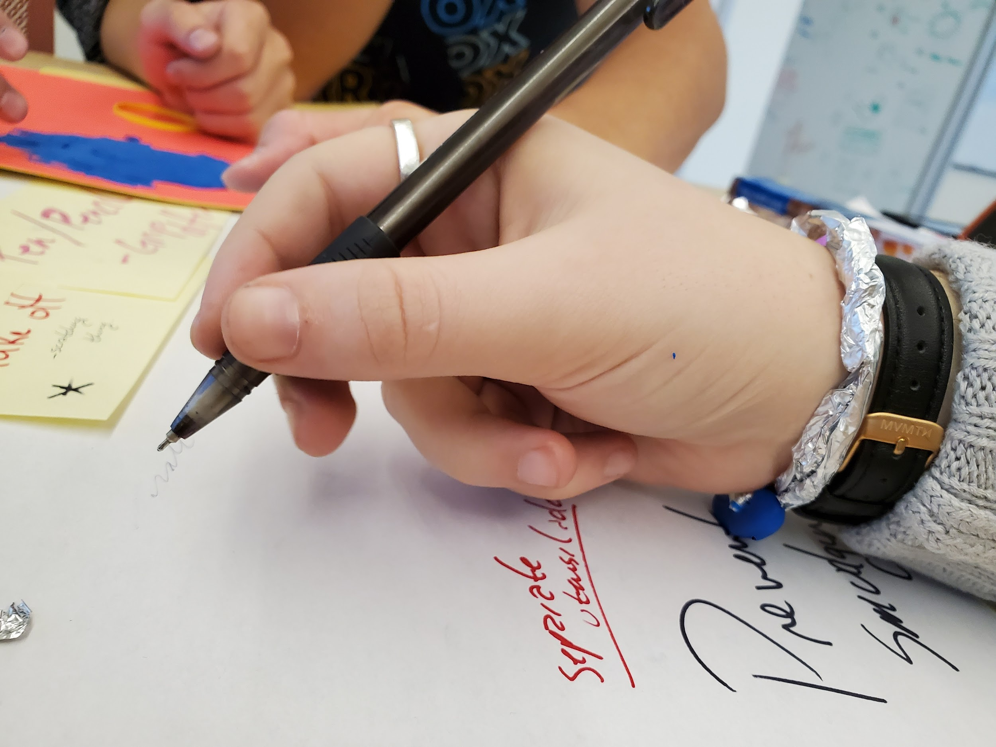

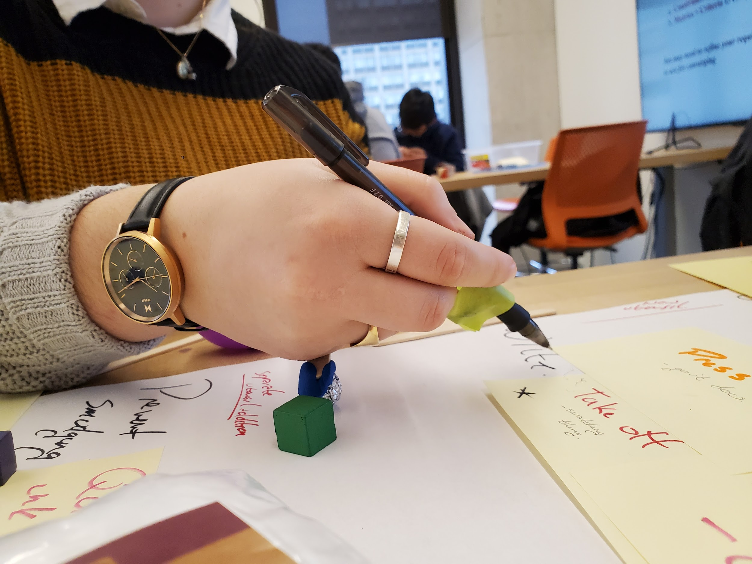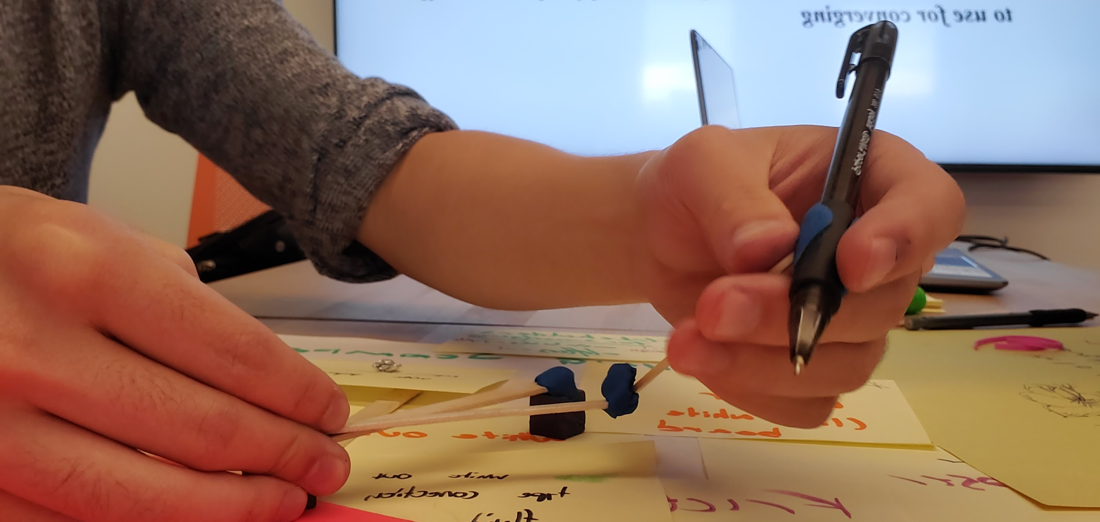
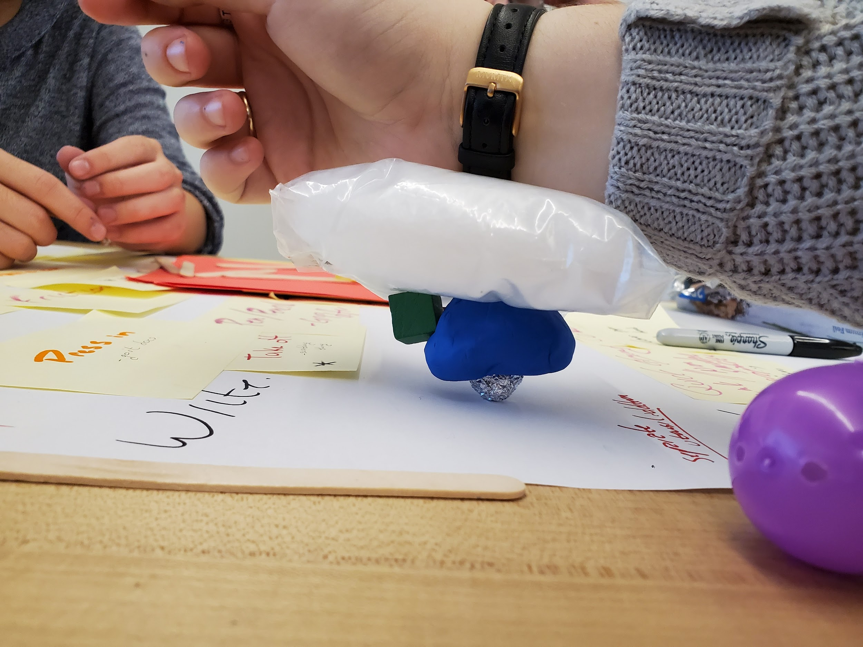
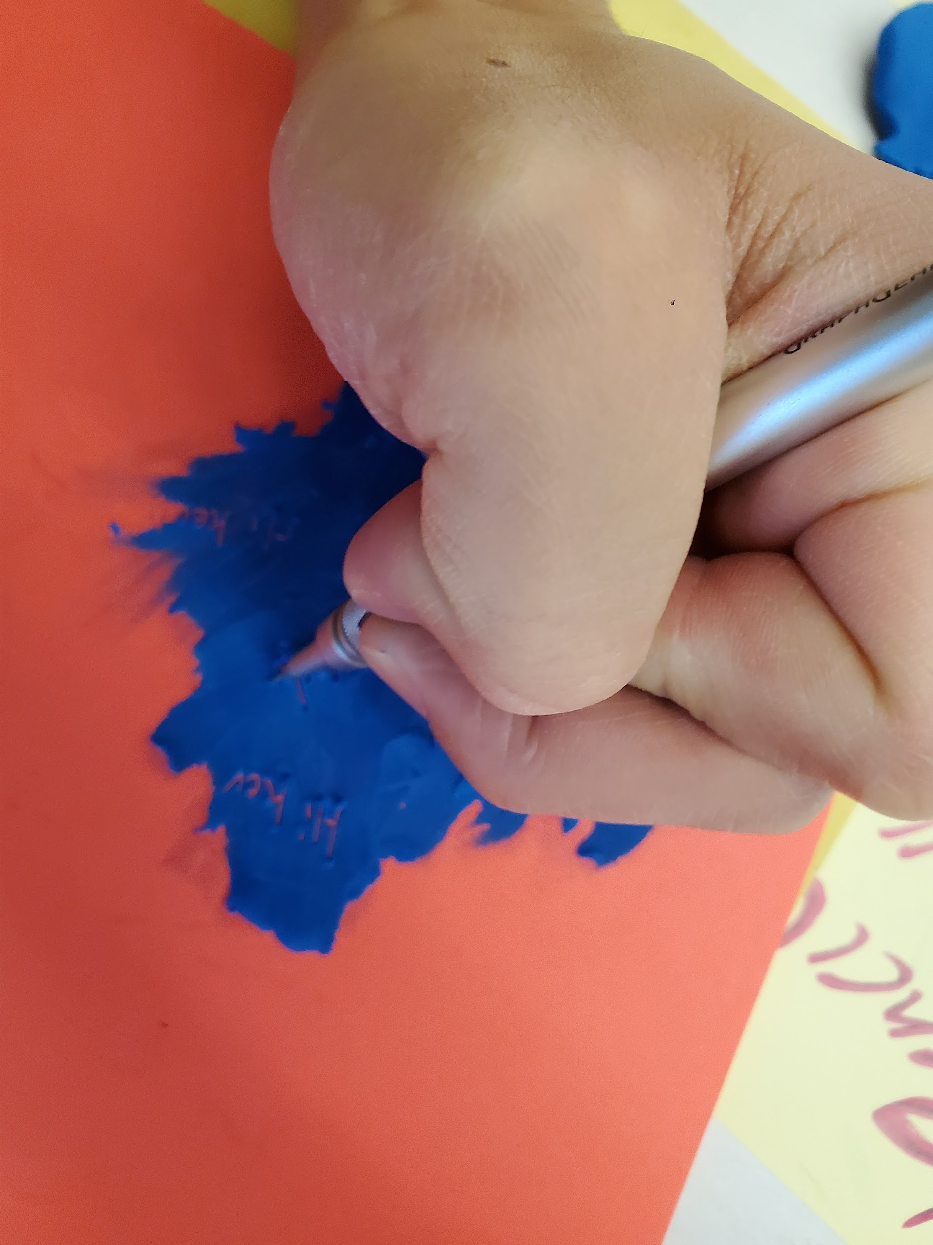

Hand ergonomics research:
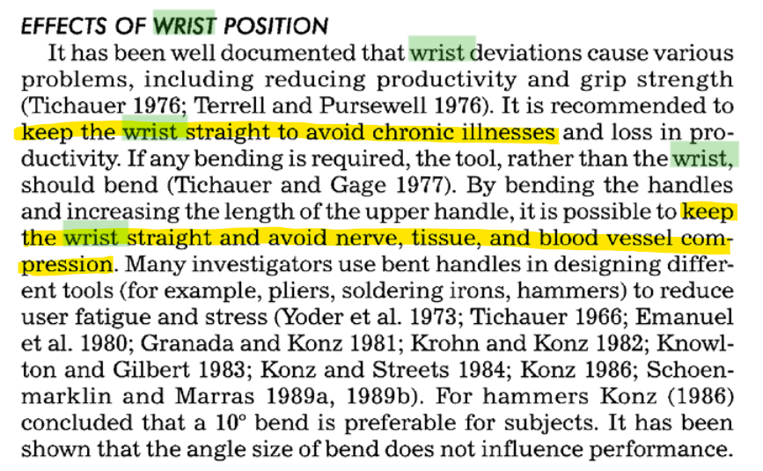

Karwowski, Waldemar Salvendy, Gavriel. (1998). Ergonomics in Manufacturing - Raising Productivity through Workplace Improvement - 5.3.4.1 Effects of Right-Handed versus Left-Handed Operators. Society of Manufacturing Engineers (SME). Retrieved from
https://app.knovel.com/hotlink/pdf/id:kt00TVY601/ergonomics-in-manufacturing/effects-right-handed

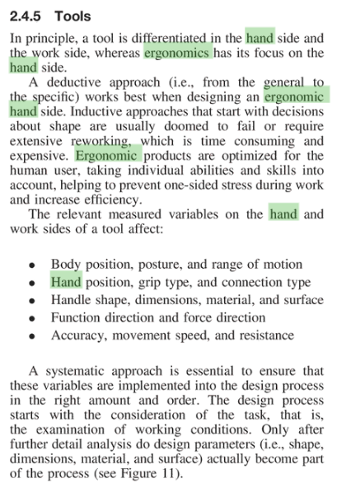
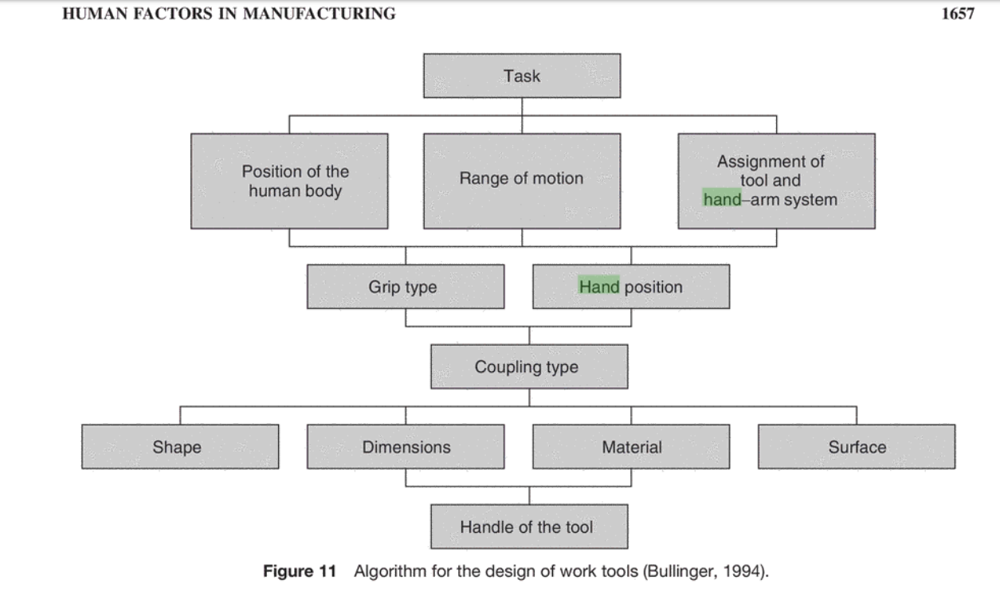
Salvendy, Gavriel. (2012). Handbook of Human Factors and Ergonomics (4th Edition) - 60.2.4.6 Workplace Design. John Wiley & Sons. Retrieved from
https://app.knovel.com/hotlink/pdf/id:kt011U5ZQ3/handbook-human-factors/work-syste-workplace-design

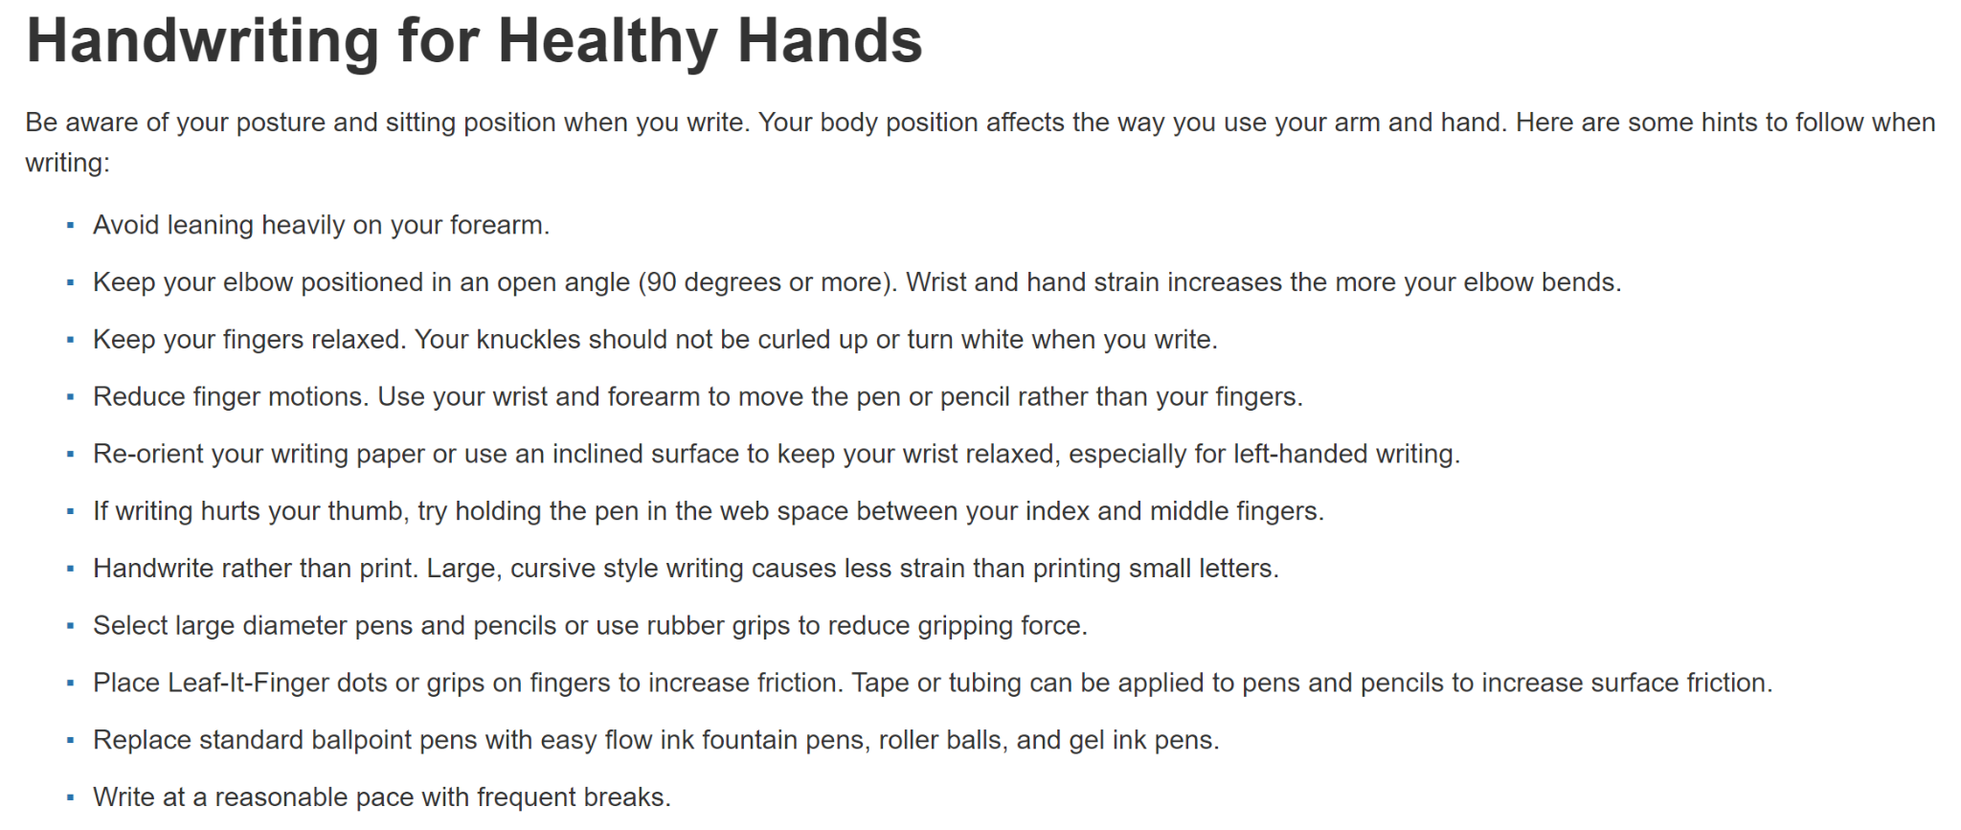
https://www.ergonomics.ucla.edu/injuries-and-prevention/handwriting-tips

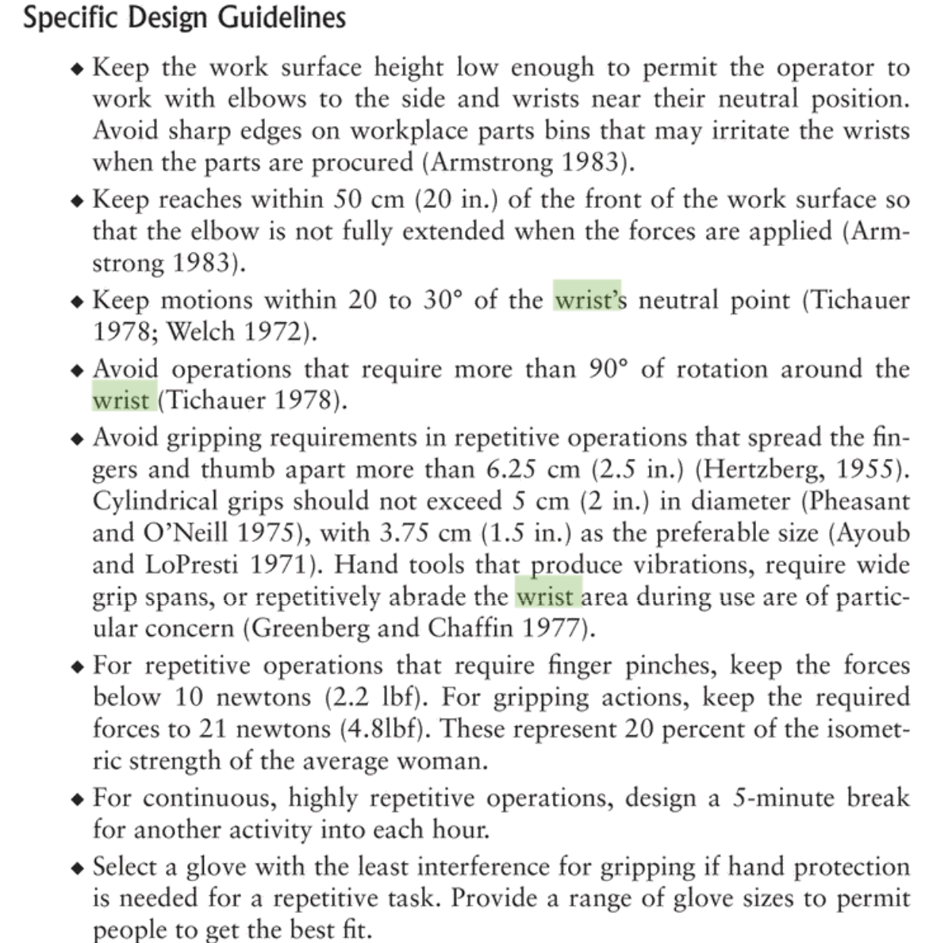

https://app-knovel-com.myaccess.library.utoronto.ca/web/view/khtml/show.v/rcid:kpKEDPWE04/cid:kt003XW088/viewerType:khtml//root_slug:kodaks-ergonomic-design/url_slug:individual-risk-factors?b-q=wrist%20ergonomics%20writing&include_synonyms=no&sort_on=default&page=46&view=collapsed&zoom=1&q=wrist%20ergonomics%20writing

